**191. Airties Cloud: AWS & DevOps Bootcamp Ödev-5**

AWS CDK kullanarak S3 bucket’ı oluşturma. İstediğiniz herhangi bir dilde yapabilirsiniz.

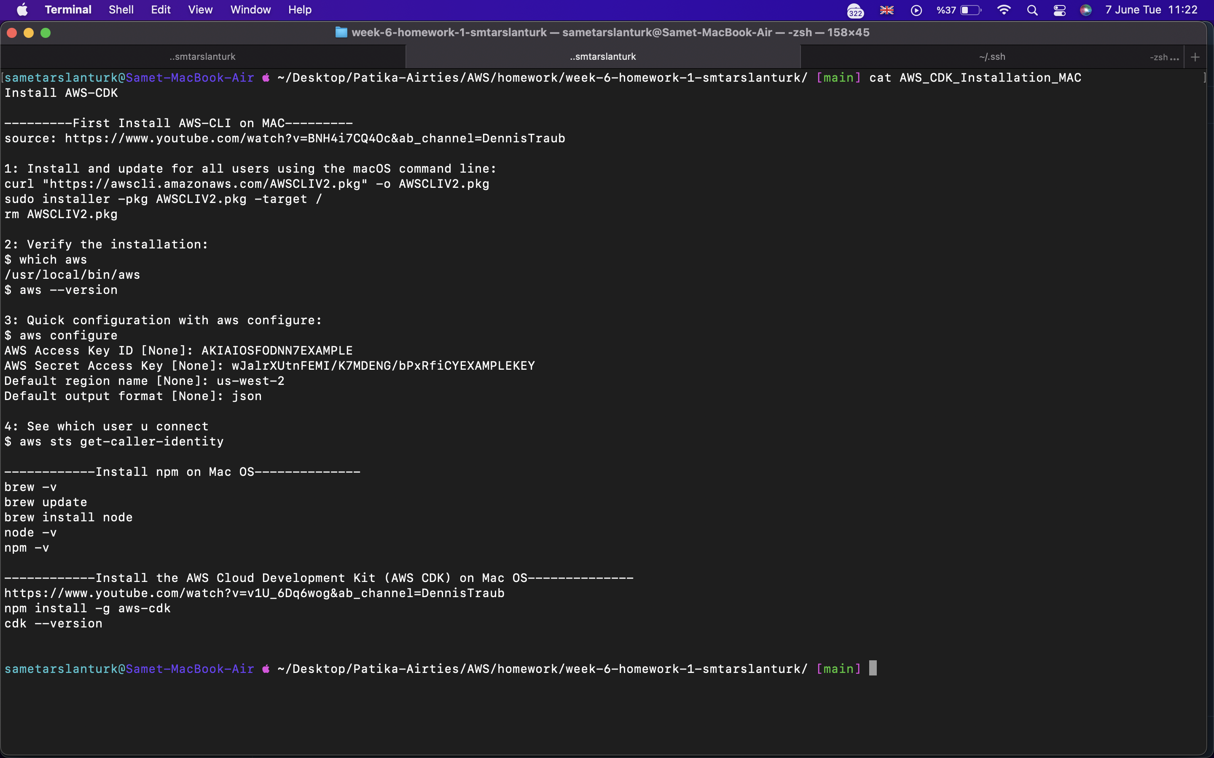

AWS CDK install

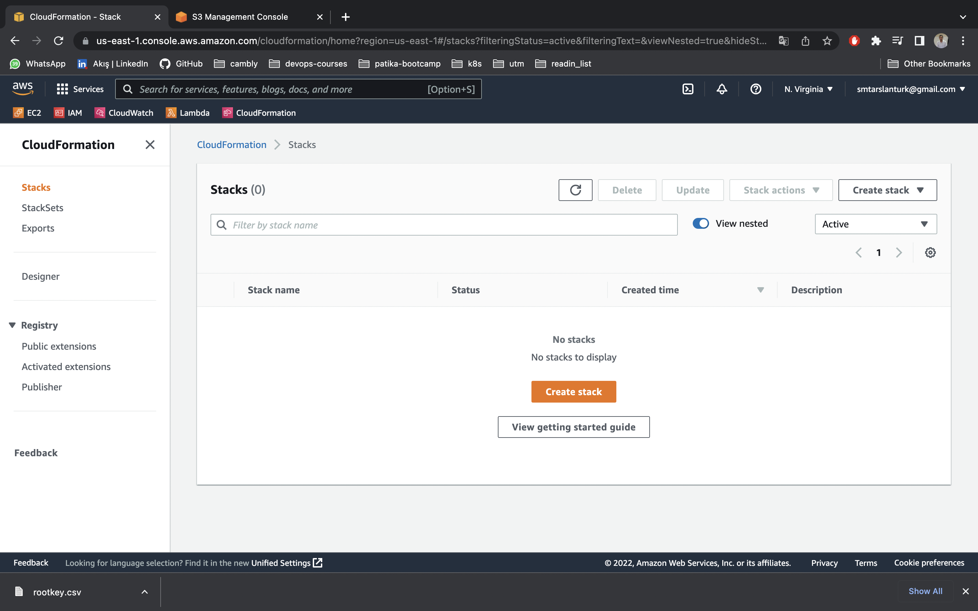

No Stack

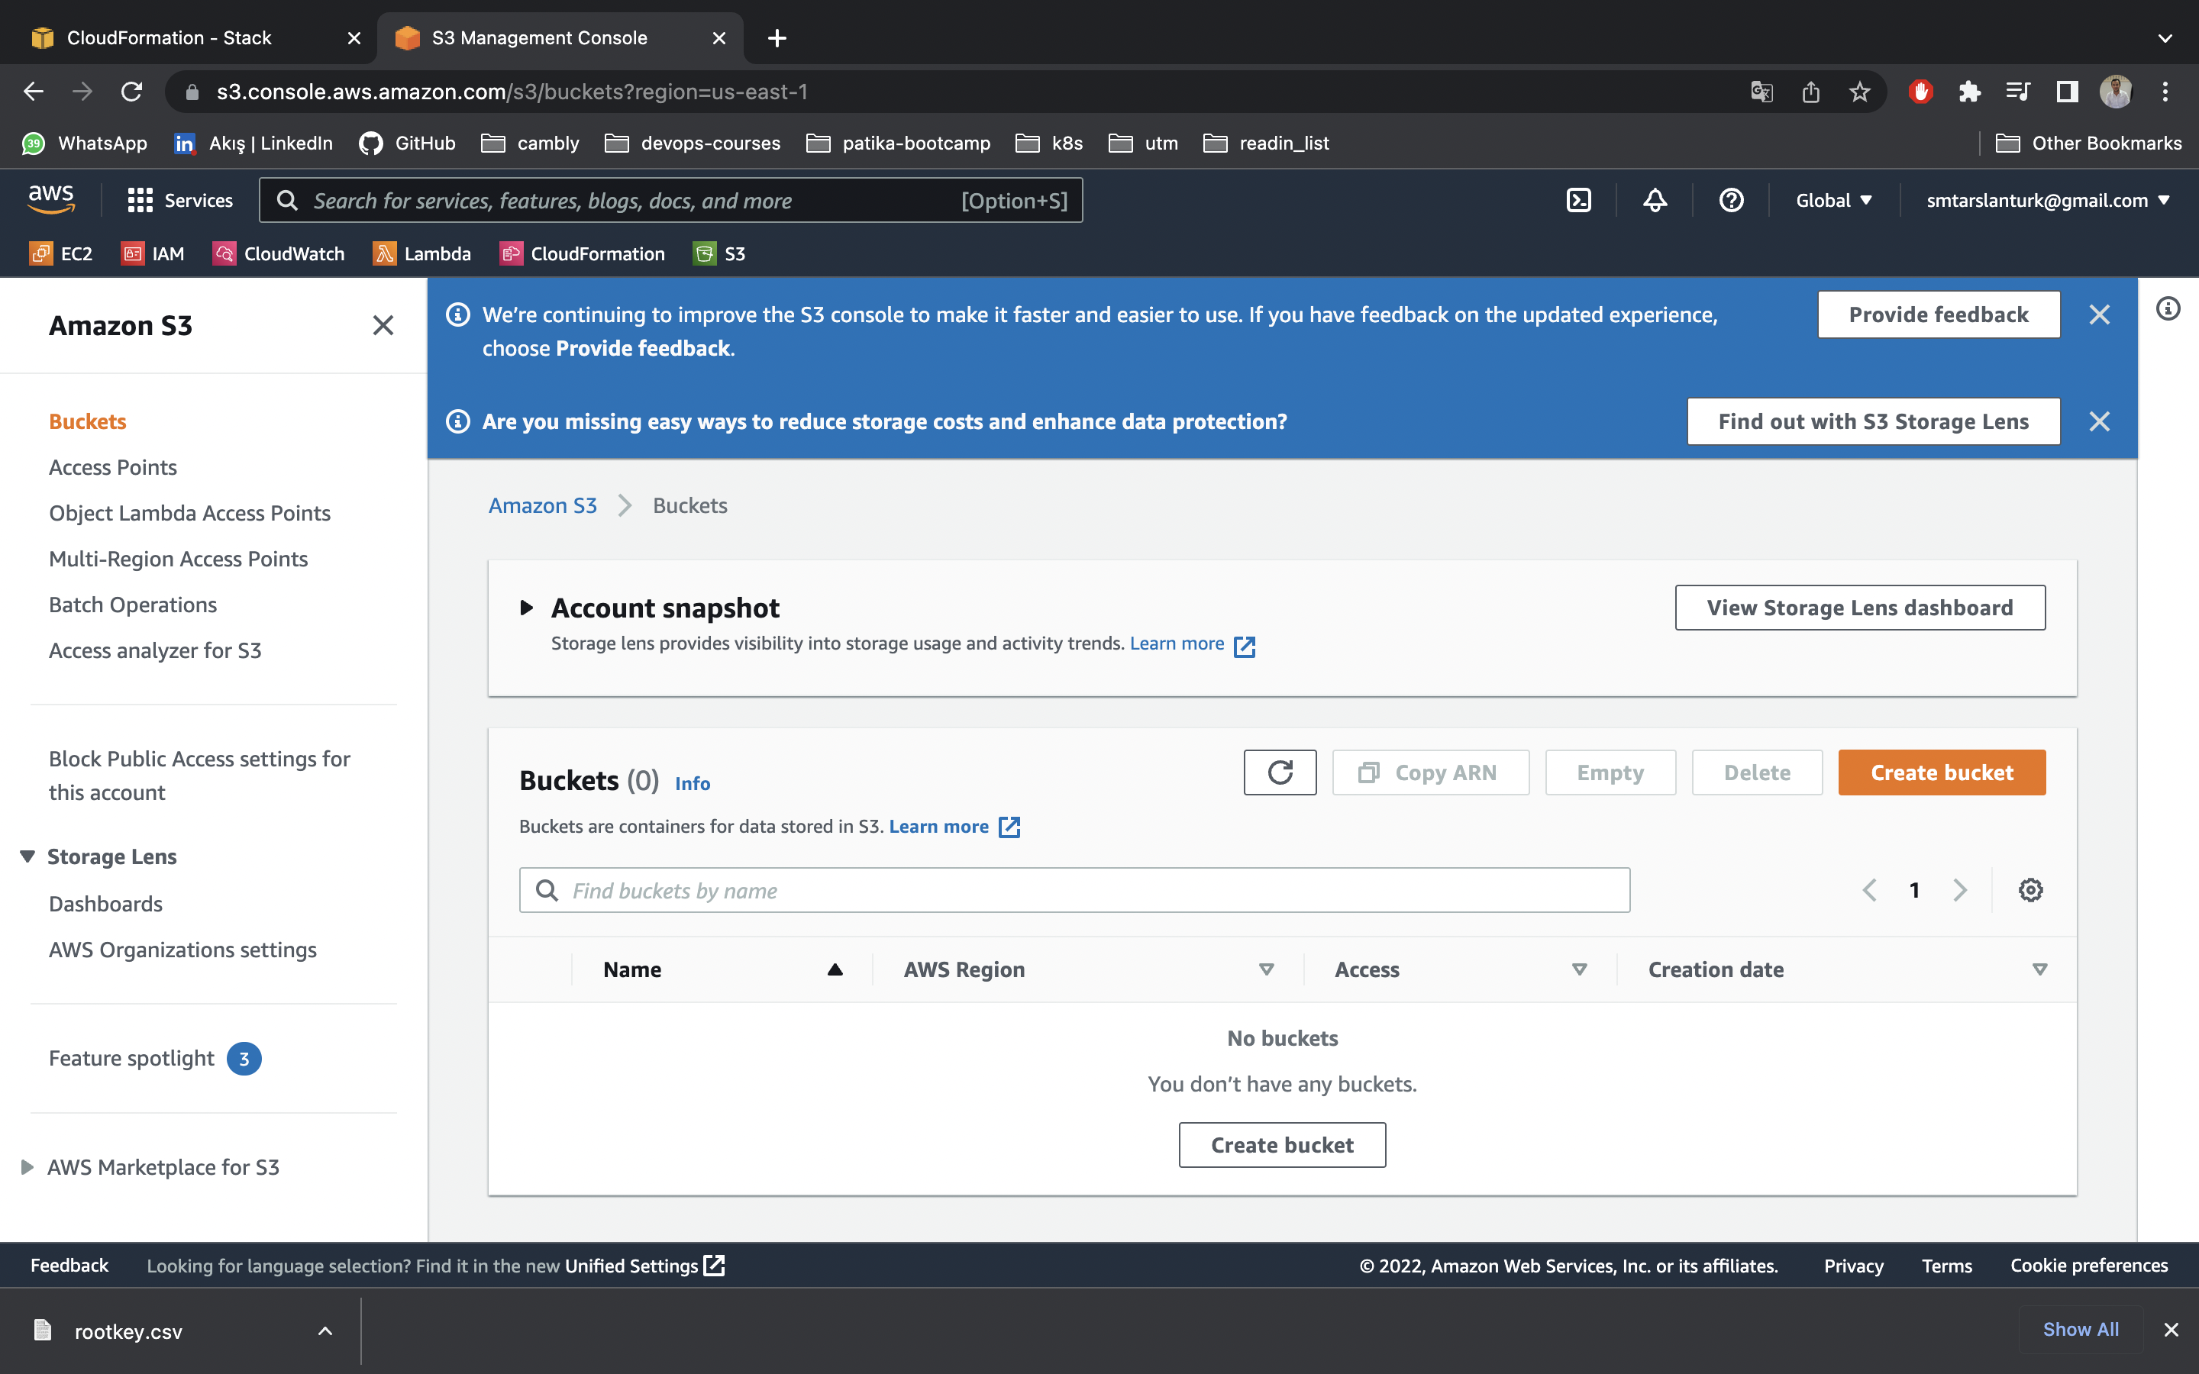

No S3 Bucket

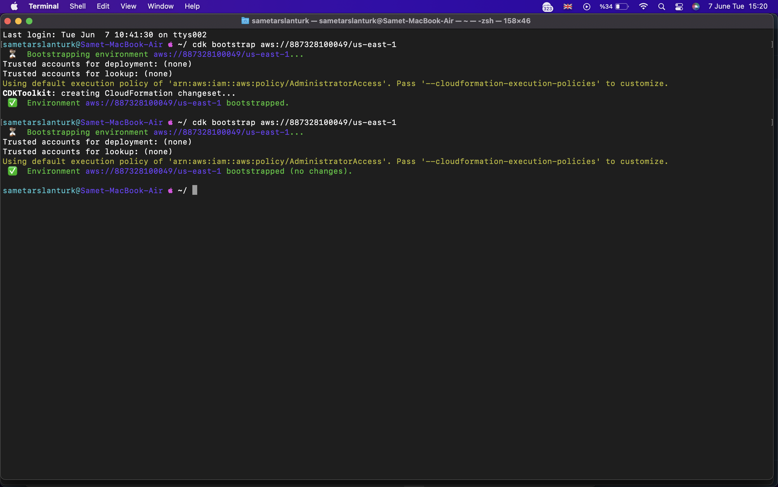

AWS Bootstrap process

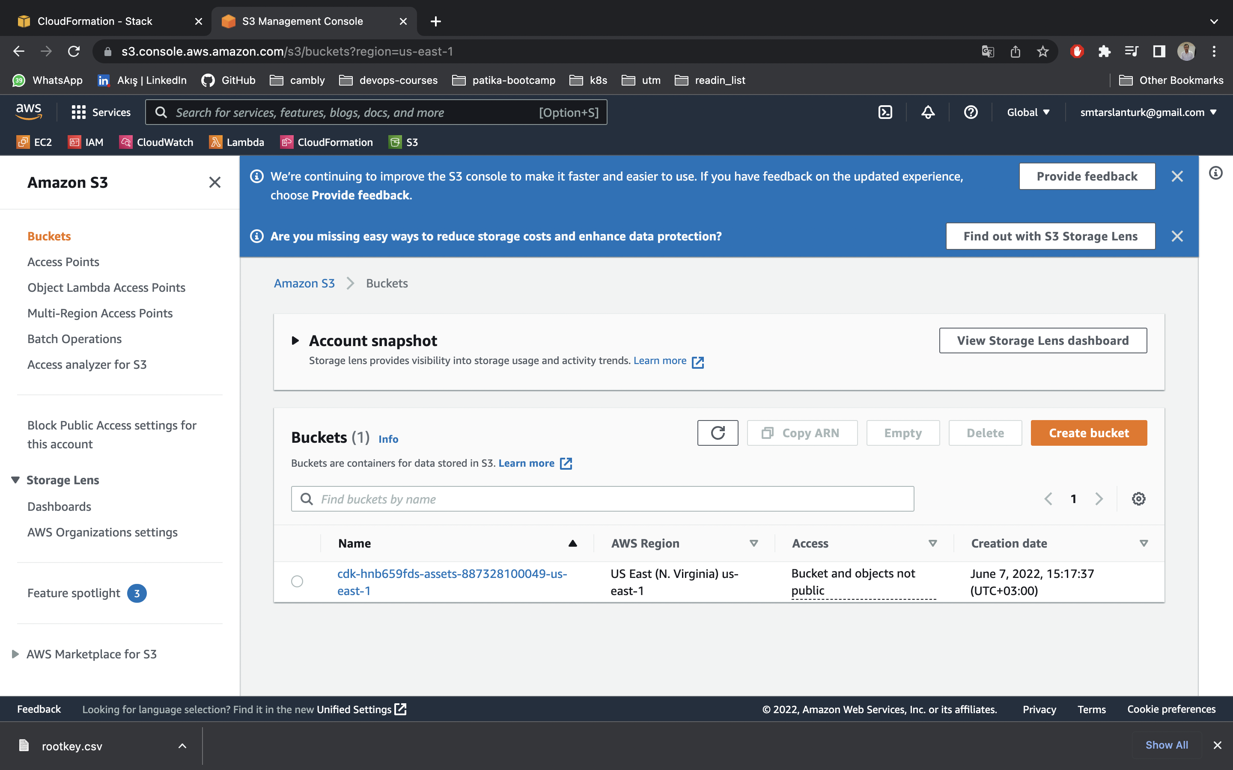

S3 Site After Bootstrap

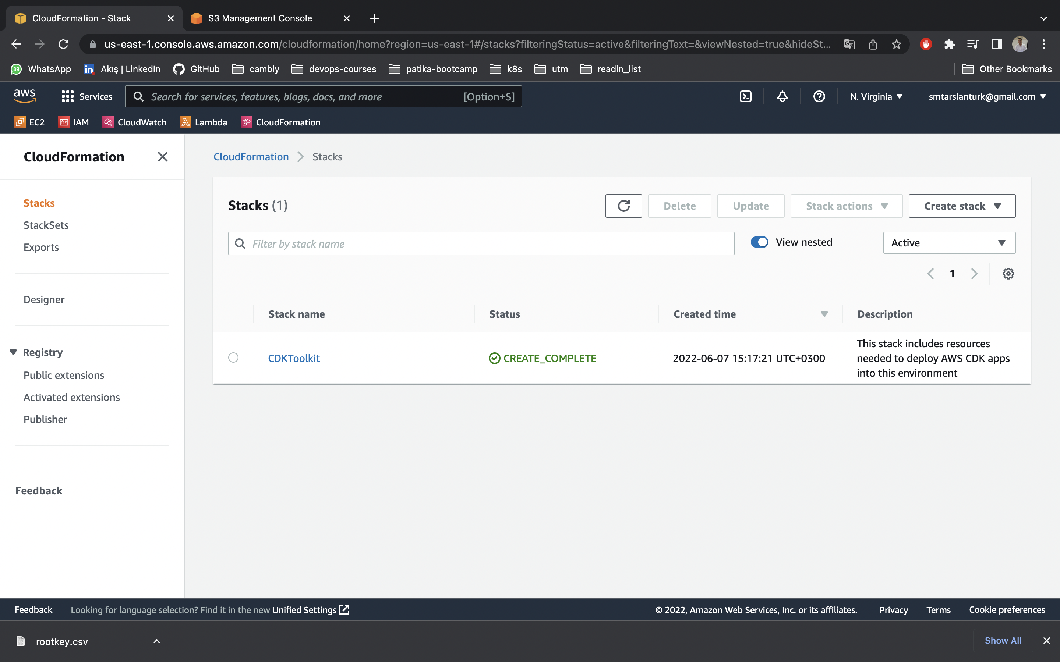

CloudFormation Site After Bootstrap

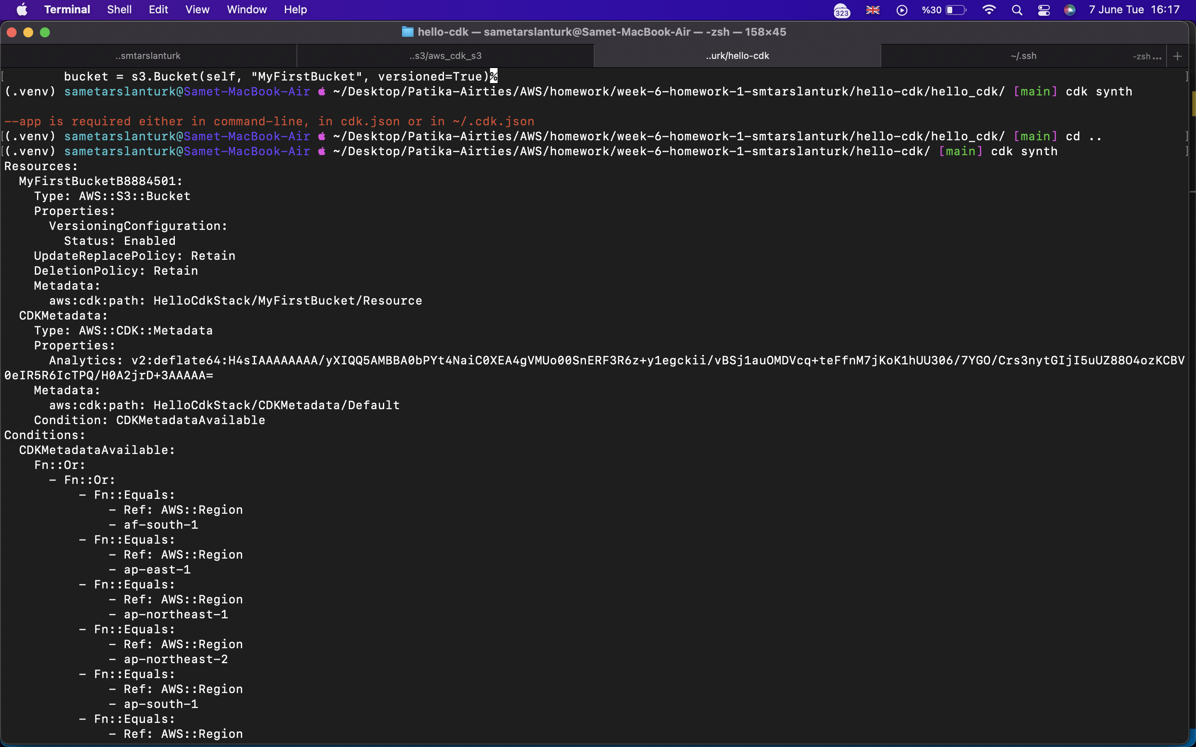

After cdk synth command

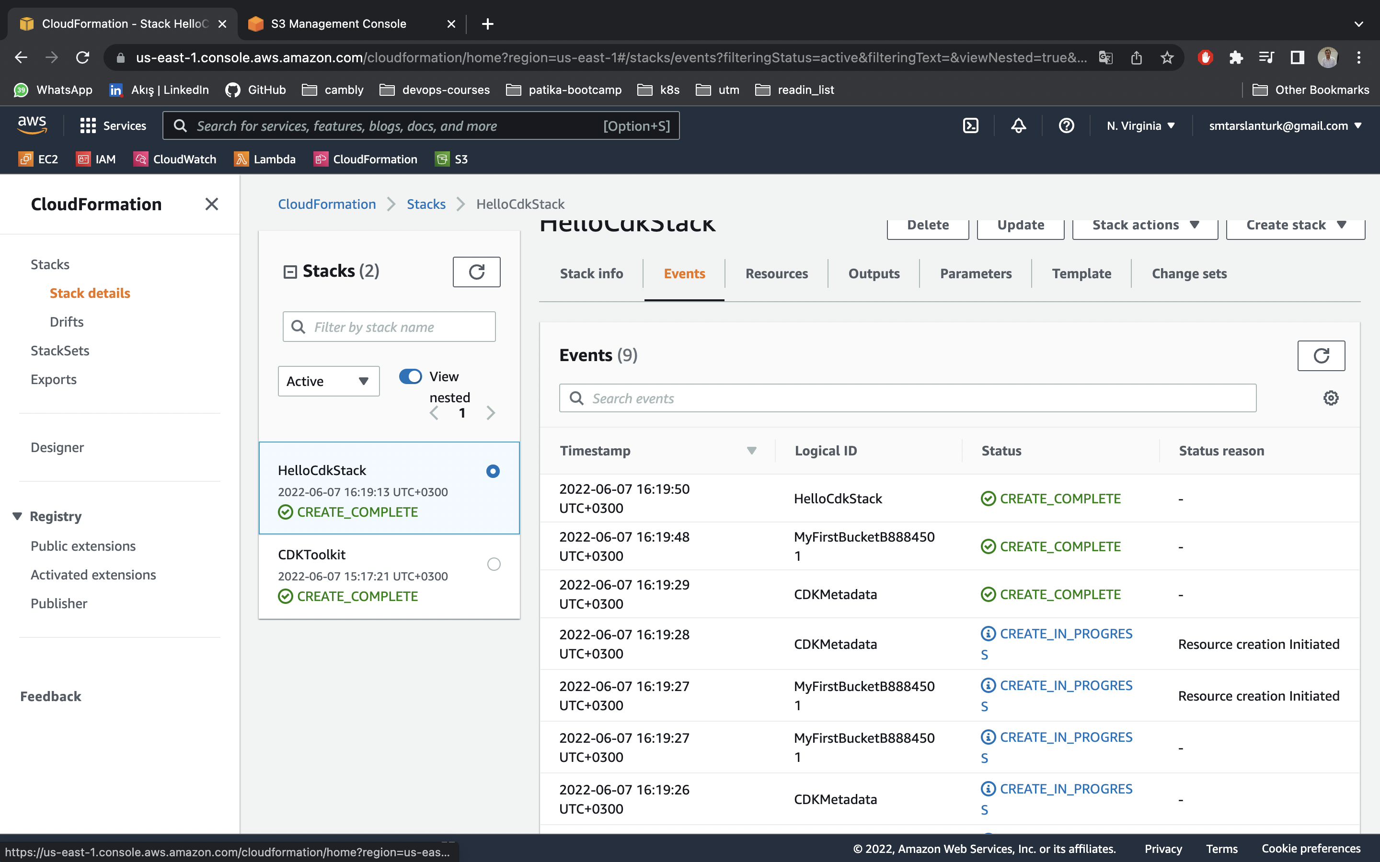

Stacks Events After Deploy

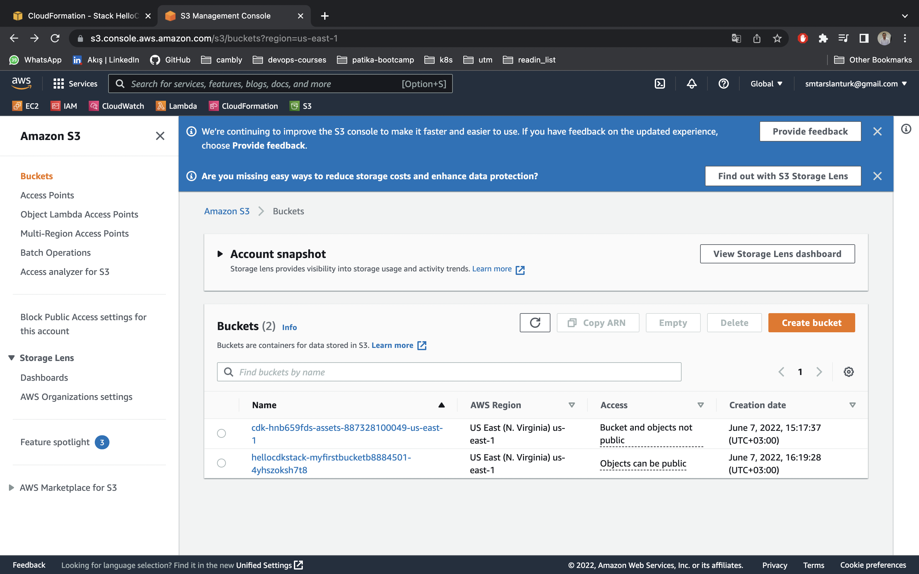

We can access created S3 Bucket by AWS cdk.